TITLE:Classification of Arrythmia by using deep learning 2-D ECG spectral Image representation

TEAM ID:PNT2022TMID40581

DATE:19 November 2022

**Importing Libraries**

Build Python Code

The first step is usually importing the libraries that will be needed in theprogram.

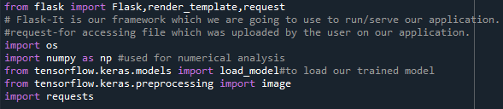

Importing the flask module into the project is mandatory. An object of theFlask class is our WSGI application. Flask constructor takes the name of thecurrent module ( name ) as an argument Pickle library to load the model file.